1. Create repository on github
2. Clone into a empty folder (create folder first)
   1. 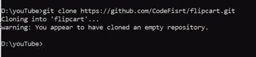
3. Create new angular project into cloned folder
   1. 
   2. Because of above statement, there will be filpcart folder inside flipcat folder so copy files from inner flipcart folder to outer
4. Open angular project into vs code
5. Add some webpage code in app.c.html
6. Publishing project on github pages
   1. Install package – ng-cli-ghpages
   2. 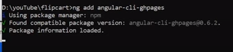
   3. Push code on github
      1. Flipcart>Git status
      2. Flipcart>Git add .
      3. Flipcart>git commit –m “first commit”
      4. Flipcart>git push
   4. Go to github and refresh
   5. Setting up github pages
      1. On github -> go to setting -> pages ->
         1. Source -> deploy from branch
         2. branch -> main -> save
7. build angular application
   1. 
8. Deploy angular application
   1. 
9. Change branch in github setting
   1. 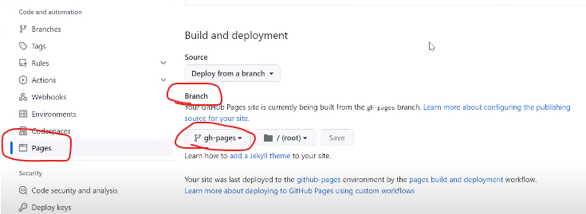
10. DONE